**Practical No 3:**

**Aim:** Project Table Identifications: Table Names, Table Attributes, Primary Keys, Foreign Keys, Integrity Constraints, Data Types, Referencing

Project Schema Creations: Formal joining of identified tables and checking of constraints

**Attributes all table**

**Clerk**

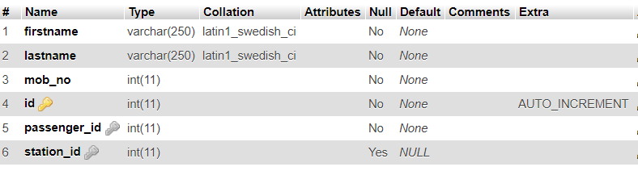

**Passenger**

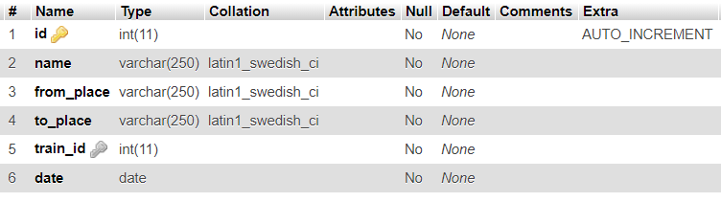

**Payment**

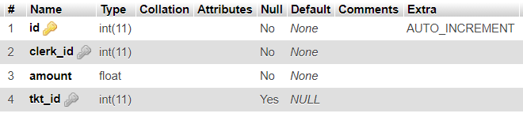

**Station**

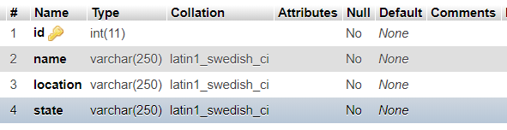

**Ticket**

Train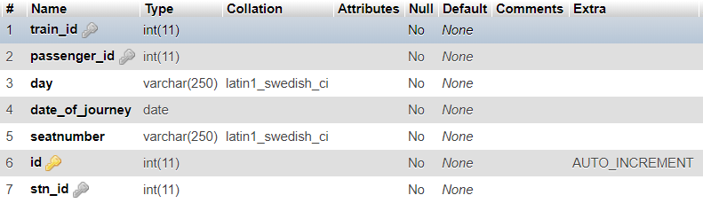

**Train**

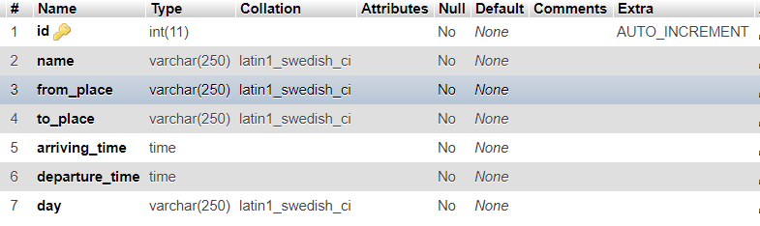

**Schema Diagram**

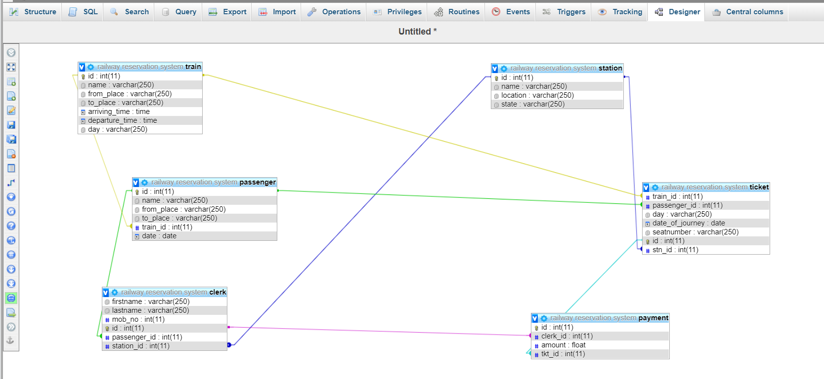

* The train table stores the data of the trains, data such as the train is running from where to where.
* Passenger table is having the train_id as the foreign key to tell which passenger is travelling by which train.
* Clerk is the table which is having the passenger id and station id to tell on which station he is posted and the passenger id of which he is entertaining and the general information about the clerk.
* Payment is the table which tells the amount of the ticket as it is having the tkt_id and clerk_id as forign key.
* Ticket is the table which is havig the info about the ticket and train id passenger id and the station id as forign key and the general information about the seat number and date of the journey.
* Station is the table having the information about station.

**Queries:**

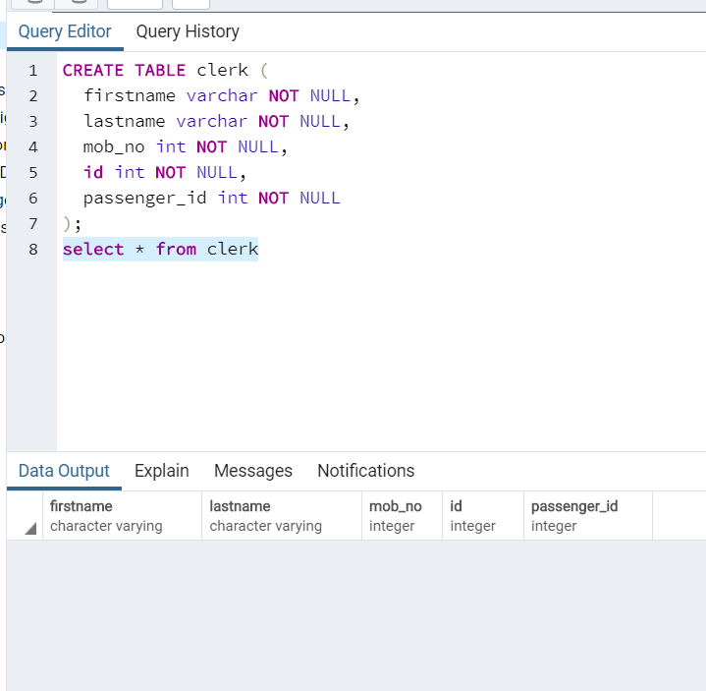

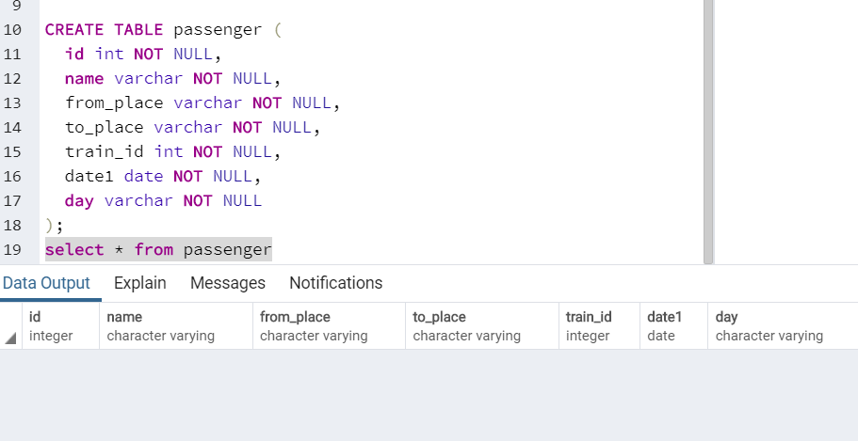

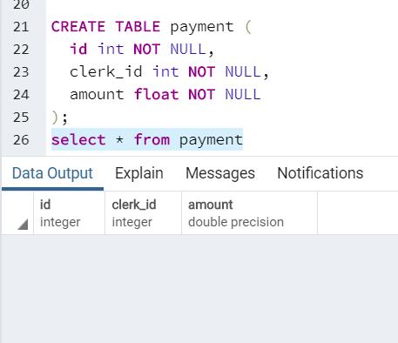

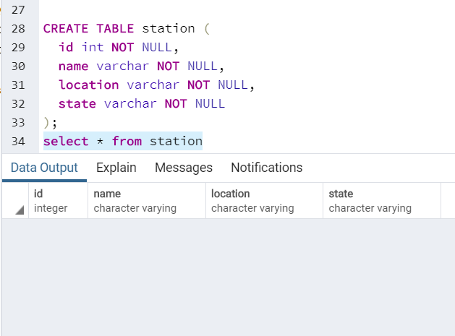

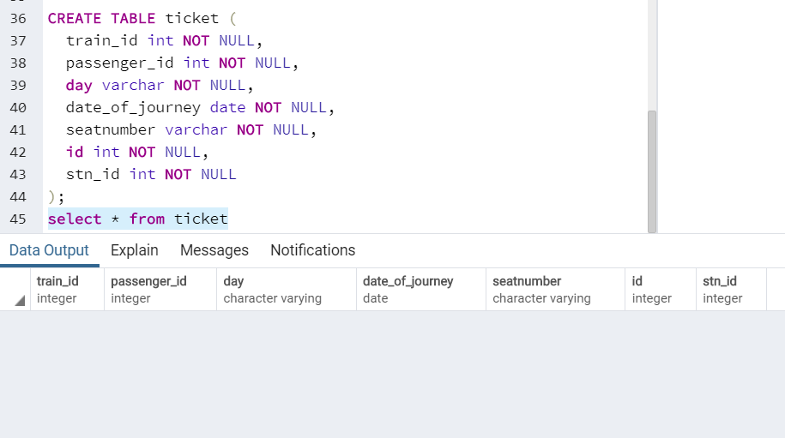

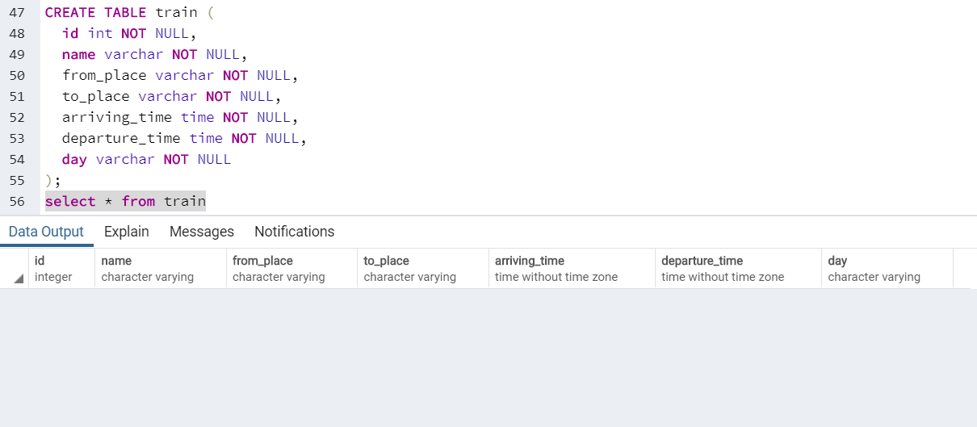

`INSERT INTO clerk (firstname, lastname, mob_no, id, passenger_id, station_id) VALUES

('himanshu', 'shekhar', 123456789, 1, 2, 1),

('anurag', 'fulare', 123456798, 2, 1, 2),

('mridul', 'riothiya', 1234569, 3, 4, 2),

('mrunal', 'zire', 789456132, 4, 3, 1);

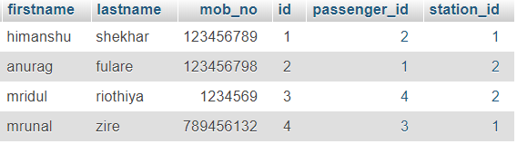

INSERT INTO passenger (id, name, from_place, to_place, train_id, date) VALUES

(1, 'himanshu', 'nagpur', 'delhi', 1, '2019-07-09'),

(2, 'anurag', 'nagpur', 'delhi', 1, '2019-07-09'),

(3, 'mridul', 'nagpur', 'mumbai', 2, '2019-07-17'),

(4, 'mrunal', 'nagpur', 'mumbai', 2, '2019-07-24');

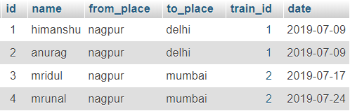

INSERT INTO payment (id, clerk_id, amount, tkt_id) VALUES

(1, 2, 3000, 1),

(2, 1, 5000, 4),

(3, 3, 6000, 2),

(4, 1, 10000, 3);

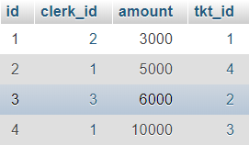

INSERT INTO `station` (`id`, `name`, `location`, `state`) VALUES

(1, 'ajni', 'ajni', 'maharashtra'),

(2, 'nagpur central', 'nagpur', 'maharashtra');

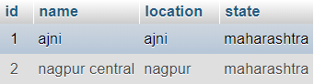

INSERT INTO `ticket` (`train_id`, `passenger_id`, `day`, `date_of_journey`, `seatnumber`, `id`, `stn_id`) VALUES

(1, 2, 'monday', '2019-07-02', 'A34', 1, 2),

(1, 1, 'tuesday', '2019-07-09', 'S56', 2, 2),

(2, 3, 'wednesday', '2019-07-17', 'A98', 3, 2),

(2, 4, 'satusday', '2019-07-16', 'g56', 4, 2);

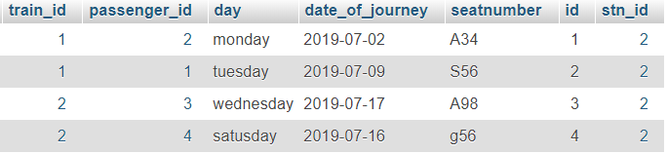

INSERT INTO `train` (`id`, `name`, `from_place`, `to_place`, `arriving_time`, `departure_time`, `day`) VALUES

(1, 'dorronto', 'nagpur', 'delhi', '07:00:00', '20:00:00', 'monday'),

(2, 'xyz express', 'nagpur', 'mumbai', '07:00:00', '20:00:00', 'tuesday');

